**TUGAS TAMBAHAN KELAS XII BAHASA & SASTRA INGGRIS SEMESTER GANJIL TP 2023 -2024**



**DAVID RIBOCH**

**XII MIPA 2**

**SMA NEGERI 99 JAKARTA**

**Jalan Cibubur II, Kel. Cibubur, Kec. Ciracas– Jakarta Timur**

1. **DESCRIPTIVE TEXT**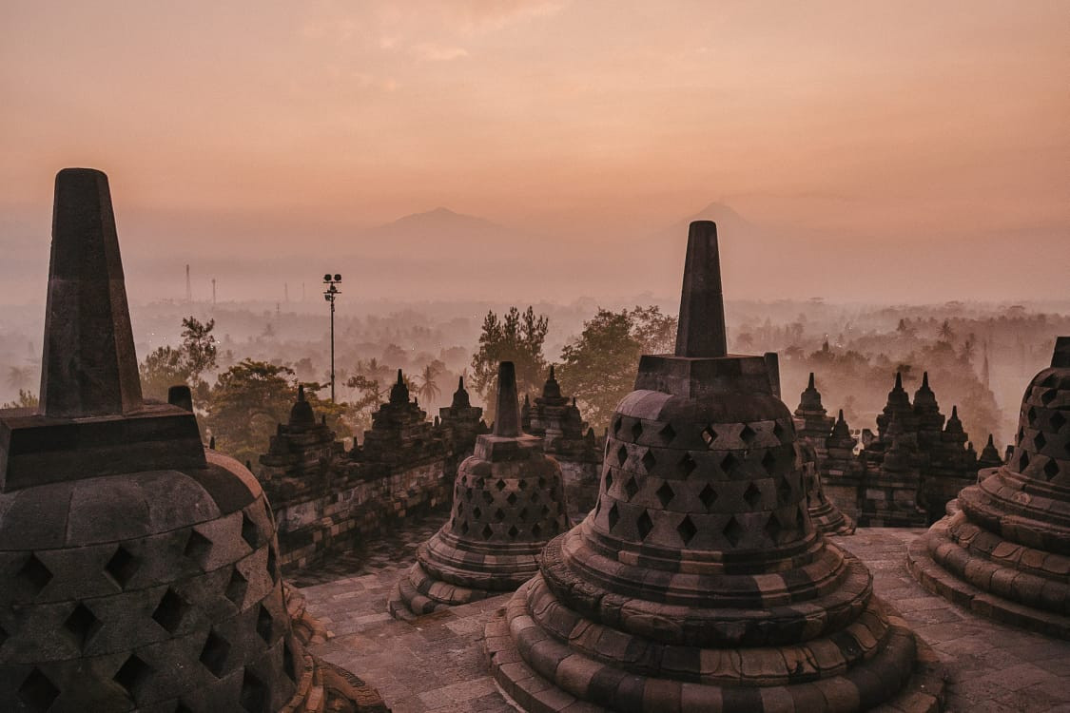

**1.1 Definition**

A descriptive text is a type of writing that paints a vivid picture of a person, place, object, or event through detailed sensory observations. The goal of a descriptive text is to engage the reader's senses, allowing them to visualize and experience the subject. Descriptive texts often use rich language, sensory details, and vivid imagery to create a lasting impression.

**1.2 Structures**

1. **Introduction**: Introduce the subject of the description and set the tone. Capture the reader's interest by providing a brief overview of what will be described.
2. **Main Body**: Organize the description in a logical manner, moving from one detail to another. Use descriptive language to appeal to the reader's senses—sight, sound, touch, taste, and smell. Create a mental image that allows the reader to experience the subject as if they were there.
3. **Conclusion**: Summarize the key features or leave the reader with a lasting impression. Reinforce the overall mood or atmosphere created in the description.

**1.3 Example**

**A Tranquil Beach Sunset**

**Introduction:**

As the sun dipped below the horizon, casting a warm glow across the sky, I found myself standing on the deserted beach, entranced by the serene beauty unfolding before my eyes. The promise of a tranquil sunset beckoned, and I eagerly embraced the quietude that enveloped the coastal landscape.

**Main Body:**

The sky transformed into a canvas of pastel hues, with shades of pink, orange, and gold blending seamlessly. Wispy clouds caught the last rays of daylight, casting a gentle blush over the expanse of the ocean. The rhythmic lull of the waves provided a soothing soundtrack, echoing the peaceful rhythm of the natural world.

As the sun continued its descent, the sand beneath my bare feet grew cool, contrasting with the lingering warmth in the air. Seagulls circled overhead, their silhouettes adding a touch of grace to the fading light. A gentle breeze carried the scent of saltwater, invigorating the senses and enhancing the coastal ambiance.

The silhouette of a lone palm tree stood tall against the backdrop of the setting sun, its fronds swaying in the breeze. The beach, painted in hues of soft pastels, transformed into a tranquil haven, inviting quiet reflection and appreciation for the beauty of nature.

**Conclusion:**

As the sun completed its descent, leaving behind a trail of soft twilight, the tranquil beachscape imprinted itself on my memory. The ephemeral beauty of the sunset, the calming sounds of the ocean, and the gentle rustle of palm leaves created a moment of pure serenity. In the embrace of this coastal paradise, time seemed to stand still, leaving me with a lasting appreciation for the simple yet profound beauty of a beach sunset.

**1.4 Questions**

**What is the primary purpose of the descriptive text?**

a. To entertain

b. To persuade

c. To inform

d. To analyze

e. To vividly portray a person, place, or thing

Answer:

The correct answer is e. To vividly portray a person, place, or thing.

**Which of the following is a key feature of the language used in the descriptive text?**

a. Objective tone

b. Emotional appeals

c. Descriptive language

d. Ambiguous statements

e. Historical references

Answer:

The correct answer is c. Descriptive language.

**The descriptive text likely includes:**

a. A chronological sequence of events

b. Statistical data

c. Dialogue between characters

d. Personal opinions

e. Arguments and counterarguments

Answer:

The correct answer is d. Personal opinions.

# REPORT TEXT



## 2.1 Definition

A Report text is a type of text in English that explains the details of an object. The explanations in the report text are the result of observations, research, observations and studies regarding various things.

## 2.2 Structure

1. General classification

The first structure is the first part which contains various general information based on the results of observations made by the author. The results of these observations can include animals, natural phenomena, plants and other topics in detail.

2. Description

The second structure of the report text is in the second paragraph and has the same function as descriptive text, namely to describe in more depth the details of the author's research results in detail.

## 2.3 Characteristics of Report Text

Report text has certain characteristics that differentiate it from descriptive text. These characteristics include the following:

* Report text explains various groups and not specific individuals.
* Contains scientific facts.
* The title in the report text looks general. This means that the title is easily recognized by the reader, even though the reader does not have competence in the scientific topic in the report text.
* Generally accompanied by images and statistical data to support the author's observations.
* Use simple present tense sentence patterns.
* Using general nouns as in the language feature general nouns.
* Using verbs that are related to each other, according to the language feature, namely linking verbs or relative verbs.
* Consists of an object and added with other objects.
* Using conditional logical conjunctions, for example so, when, and so on.

# Giraffe

# The giraffe is the highest animal in the world. Its height can reach 4.8 to 5.5 meters and its weight is about 1360 pounds. Giraffe has unique characteristic. They have a very long necks and two small horns on its head. Giraffes have big brown eyes and are protected by thick and long eyebrows. Her body is covered with a unique pattern that is attached by brown spots all over their body.

# Just like camels, giraffes can survive without drinking for a long time because giraffes can rely on the water contained in the leaves they eat. Giraffes are very selective in choosing food. They always eat young leaves that grow in the tree tops. Their tongue shaped like a knife help them to cut branches that are very hard.

# Female giraffes can start pregnant at the age of five years, with a gestation period of 15 months. Commonly female giraffes bear one baby, but sometimes two babies at once. Giraffes bear their baby in a standing position. When the baby is about to be born, they drop it to the ground from a 1.5-meter height. A baby giraffe can stand for about 20 minutes after being born, and begin breastfeeding within an hour of birth.

**2.4 Questions**

1. What kind of text is above?

A. Report text

B. Descriptive text

C. Narrative text

D. Spoof

2. The text tells us about?

A. Giraffe's reproduction

B. The strange animals

C. The highest animal

D. Baby giraffe

3. The unique characteristic of a giraffe is?

A. Two horns on its head

B. Their long neck

C. Brown spot

D. Their food

4. The second paragraph mainly discussed?

A. Giraffe's food

B. Giraffe's characteristic

C. Giraffe's life

D. Giraffe's reproduction

5. The word "it" in the third paragraph refers to?

A. Neck

B. Horn

C. Baby giraffe

D. Food

1. PROCEDUR TEXT

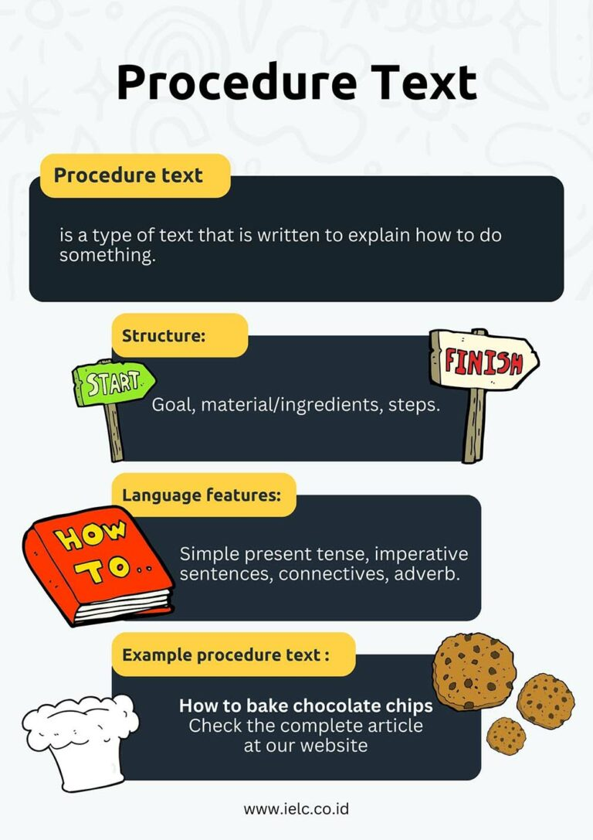

**3.1 What is a procedure text?**

A Procedure text is a type of text that is written to explain how to do something. It’s a step-by-step explanation of a process or a set of instructions for completing a specific task. Procedure text is used in many contexts, such as manuals, recipes, scientific experiments, or instructions for assembling products.

**3.2 What is the structure of a procedure text?**

**1. Goal**

The goal is the starting point of a procedure text. It sets the stage by providing a clear statement of what the reader is trying to achieve by following the instructions. It gives context and purpose, helping the reader to understand why they are undertaking the task.

For example, in a recipe, the aim might be to bake a chocolate cake. In a science experiment, the goal could be to demonstrate a particular chemical reaction. By stating the aim or goal, the reader can focus on what needs to be accomplished.

**2. Materials or ingredients**

This section provides a comprehensive list of everything needed to carry out the task. It ensures that the reader has everything at hand before starting.

Materials: This could include tools, equipment, or other supplies. For example, if you’re assembling a piece of furniture, this section would list all the required parts and tools like screws, nails, a hammer, etc.

Ingredients: In a cooking context, this refers to all the food items and quantities needed to prepare a dish. It’s like a shopping list for your recipe, ensuring you have everything you need to start cooking.

The Materials/Ingredients section is essential for preparation and helps ensure that the procedure goes smoothly from start to finish.

**3. Steps**

The Steps are the heart of a procedure text. This section provides a detailed, step-by-step guide on how to achieve the aim or goal. It breaks down the task into manageable parts, often in a chronological or logical order.

Each step is usually written in a clear and concise manner, using imperative language (commands). It’s vital that these steps are easy to understand and follow, as any ambiguity or complexity can lead to confusion or mistakes.

**3.3 What are the language features of a procedure text?**

**1. Simple present tense**

The simple present tense in a procedure text makes the action immediate and relevant. It’s as if the procedure is happening right now, in real time, guiding the reader as they perform the task.

**2. Imperative sentences**

Imperative sentences are command forms that tell someone to do something. They are direct and to the point, which is essential in instructions.

**3. Connectives**

Connectives (or conjunctions) are words or phrases that link different parts of a text. They can show the order of steps, the relationship between different parts, or add additional information.

Examples of connectives in procedure texts include words like then, next, after that, before, or finally. These words help guide the reader through the process in a logical and coherent way.

**4. Adverbs**

Adverbs can provide additional detail about how an action is to be performed, adding precision and clarity to the instructions. They can describe how, when, where, or to what extent something is done.

**3.5 EXAMPLE**

Text 1

“How to Make Cheesecake”

Ingredients:

1. ½ cup of sugar

2. 2 eggs

3. ½ teaspoon of vanilla

4. 2 packages of cream cheese

Directions:

1. Beat and blend sugar, cream cheese, and vanilla at medium speed.

2. Blend in the eggs, then stir.

3. Bake at 35 celsius for 40 minutes or until it is almost set.

4. Cool.

5. To get the best result, put it in the refrigerator for 3 hours.

6. Yield: 6 servings

7. Preparation time: 5 minutes

Cooking time: 40 minutes

1. For how many people can the cake be served?

a. 2

b. 6

c. 7

d. 4

e. 9

2. The text above is called …

a. description

b. explanation

c. report

d. procedure

e. narrative

3. The goal of the text above is to tell about …

a. how to blend vanilla dan sugar

b. how to make cheesecake

c. how to bake a cake

d. how to beat cream cheese

e. how to mix eggs with cream cheese

EXPRESSIONS

* + - 1. INTRODUCING ONE SELF

**Definiton of introducing oneself**

Introducing oneself is introducing oneself in English to others using appropriate

sentences so that others can get to know us better and closer than before. The act of

introducing yourself to someone else is known as self-introduction. You could be

introducing yourself to a new acquaintance, or you could be introducing yourself to

hundreds of people in a conference room. Fortunately, both situations require the same

type of language and body language to introduce yourself in a confident and clear

manner. When introducing yourself to others, you should strive to be both of these

things.

**Steps to Doing a Self Introduction**

In general, in carrying out a self-introduction there are several stages, methods, or you could say steps that must be paid attention to, namely Opening, Content, Closing. To find out more clearly, let's look at the review of the steps for self-introduction (in detail) below:

**1. Opening (Opening)**

In the opening part, you generally greet and ask about the news of the people you invite to meet face to face, for example:

* Hello, everyone…
* Hi, everybody, How are you today?
* Good morning/afternoon/evening, How are you?

**2. Content (Isi)**

Next, go to the contents section. However, before getting into the content, there is something that needs to be conveyed, namely the purpose. Express your goals and intentions in front of the person you are speaking to. Your goal is definitely to do a self-introduction, so the words you can convey are like:

* Let me introduce myself
* I would like to introduce myself
* I want to introduce myself
* In this opportunity, I would like to introduce myself
* May I introduce myself?
* I’m here to introduce myself

After that, go to the main content section which consists of several points, including:

1. **Personal Detail**

In this case, you can state your full name followed by a nickname.

* I am… you can call me…
* My name is… you can call me…
* My full name is… please call me…
* My name is… my friends usually call me…
* Iam Juliana Citra, you can call me Citra

**a. Asal Negara**

This point can be used as an option if you meet people from abroad, for example:

* I came from Indonesia
* I am from Indonesia

**b. Kewarganegaraan**

* I am Indonesian
* My nationality is Indonesian

**2) Identitas Diri (self-identity)**

State the place, date of birth, and also age, for example:

**a. Place and date of birth**

I was born….

**b. Umur**

State the place, date of birth, and also age, for example:

I am… years old

**3) Address**

Mention where you live or your current address, such as the name of the street and so on, for the original address, for example:

I come from...

I am from…

I come from Madura

I am from Madura

For residence, for example:

Now, I stay…

Now, I live…

4) Job or Study (Pekerjaan atau Sekolah/Kuliah)

* School, for example: I am a student of... or I study in...
* Lectures, mentioning the name of the university and department, for example: I am a student of... in major... or I study in, my major is...
* Have graduated from school or college, for example: I graduated from... in...
* Occupation, for example: I work in… as… (mention place of work and position) or I am a staff/manager (according to job position) of…. For example, I am a manager of PT. Jaya's work

Bisa menyebutkan kegiatan yang kalian senangi atau hobi, misalnya:

5) Interest

My hobby is…

My hobby are…

I like…

My activities are…

3. Closing

For closing, it generally ends with thanks, wishes, and of course closing greetings. Example:

That’s about me… I hope… and have a great day. Thank you.

This is the end of my self introduction

I think enough, thanks for your attention.

* + - 1. **Offering Something**

Offering Something is one type of expression that use when want to offer something toother people. Another definition Offer is giving an offer both physical and abstract to someone asa gift or trade, etc. In this material we can find out how to offer something in English and alsohow to accept or reject an offer. We can use the following expressions in various situations, thehost offers something to guests or when in the office wants to offer something to coworkers.Social function is to facilitate interpersonal communication between several different people.

**Example**

**Formal**

Would you like something to drink?

Would you like to go disco?

Would you like to come along?

Could I offer you a glass of lemonade?

Would you mind joining us?

Would you like a cup of coffee?

Shall I get you a bottle of water?

Would you like to leave a message?

**Informal**

What can I get for you?

Won't you have a pancake?

Do you want something to eat?

Cheese sandwich?

Chocolate?

Have some

Like one?

**EXAMPLE**

Dany: Good morning Jane, do you want an ice cream?

Jane: Oh, great! ______, I'd love one.

Dany: Chocolate or Strawberry?

Jane: Chocolate, please.

1. The suitable expression to complete the dialogue is …

A. Yes please

B. No Thanks

C. Don't bother

D. Never mind

E. Not for me

Andy: Shall I carry your luggage to your apartmen?

Boby: Yes, please!

2. The underlined word has similar meaning with ...

A. Borrow

B. Bring

C. Drop

D. Dodge

E. Leave

Indry : The box you brought looks very heavy. ________

Putry : Sure. It’s very kind of you. Thanks.

3. The suitable expression to complete the dialogue is …

A. Would you like me to help you?

B. Would I like to help me?

C. Would you like to help me?

D. Would you like to bring it for me?

E. Could you bring it for me?

**3. INSTRUCTION**

Instruction text is a type of text that aims to provide guidance or instructions on how to carry out a certain action or activity.

The purpose of instructional text is to guide the reader or user so that they can carry out an action correctly and effectively.

Examples of instructional texts include cooking recipes, instructions for using electronic devices, instructions for assembling furniture, or instructions for carrying out repairs on vehicles.

Instruction texts generally have the following characteristics:

1. Using imperative sentences (command sentences)

2. Use clear and concise grammar

3. Contains systematic and orderly steps or sequences of actions

4. Use technical terms or words that are relevant to the topic of instruction

5. Use symbols, images or diagrams to support the text.

In writing instructional texts, the writer must pay attention to the purpose of the reading, the target reader, and the language used so that the reader can easily understand and follow the instructions given.

**Instruction Text Structure**

The general structure of instruction text consists of three main parts, namely:

**1. Purpose (Purpose)**

The first part of the instruction text explains the purpose or use of the action to be carried out.

This objective must be clear and easy for readers to understand so that they can follow the instructions given properly.

**2. Steps (Steps)**

The third part is the steps or sequence of actions that must be carried out by the reader to achieve the desired goal

These steps must be explained in detail and orderly, using clear and concise imperative or command sentences.

Apart from that, these steps can also be supported with pictures, diagrams or symbols to make it easier to understand and follow.

In addition, in some instructional texts, structures in the form of ingredients and ingredients are usually added before the steps.

Difference between Instruction Text and Procedure Text.

**EXAMPLE Instruction Text**

Earthquake Evacuation Procedure

This is an instruction of self-evacuation of during earthquake:

- When the earthquake occurs, drop down to the ground and take cover under a sturdy desk or table. If you cannot find any cover, cover your head and neck with your hands and arms.

- Stay in the cover position until the shaking stops. Hold on to the desk or table if possible.

- After the shaking stops, evacuate the building immediately.

- Do not use elevators.

- Follow the emergency evacuation signs and exit the building through the nearest emergency exit. Be aware of fallen debris or damaged structures.

- Move away from the building and find an open space, preferably away from trees, power lines, or other potential hazards.

- Once you are in a safe location, wait for further instructions from authorities or emergency personnel.

- If you are trapped in debris, try to make noise to alert rescue personnel.

- Do not move around unless absolutely necessary to avoid further injuries!

Important to remember to remain calm and follow these instructions carefully.

Be prepared to take care of yourself and your loved ones until help arrives.

GRAMMAR

ABSTRACT NOUNS

Abstract nouns are intangible nouns that cannot be perceived by the five senses. Abstract nouns include feelings, idealism, qualities, characteristics, and actions. Examples include sorrow, belief, truth, religion, taste, disbelief, heaven, movement, and adventure.

Abstract nouns are words that refer to intangible concepts, ideas, qualities, emotions, or states rather than concrete objects or physical entities. They represent things that we can perceive with our senses, but cannot touch or see. Examples include:

Love: An emotion or feeling.

Happiness: A state of being joyful or content.

Justice: A concept related to fairness and moral rightness.

Courage: A quality of bravery or strength in facing difficulties.

Freedom: An abstract idea concerning the absence of restrictions or limitations.

Abstract nouns often embody concepts that are essential to human experiences and understanding but are not tangible or visible in the physical world. They express emotions, qualities, ideas, and states of being that shape our perceptions and interactions.

**EXAMPLE**

**1. Identifikasi abstract noun dalam kalimat berikut:**

**"The beauty of the sunset took my breath away."**

**Jawaban: Abstract noun dalam kalimat tersebut adalah "beauty".**

**2. Pilih abstract noun dalam kalimat di bawah ini:**

**a) "The cat chased the mouse."**

**b) "Her kindness towards strangers was remarkable."**

**c) "I bought a new book yesterday."**

**Jawaban: Abstract noun adalah pilihan (b) "kindness".**

**3. Buat kalimat menggunakan abstract noun "peace".**

**Contoh Jawaban: "Despite the chaos around us, she found inner peace."**

**4. Gantilah kata benda konkret dengan abstract noun yang sesuai:**

**"The strength of the bridge ensured its durability."**

**2. REGULAR VERB DAN IRREGULAR VERB**

**Regular Verbs:**

**Regular verbs are verbs that follow a fixed conjugation pattern to form the past and participle forms by adding the suffix "-ed" at the end of the word.**

**Contoh regular verb: "talk"**

**Present Tense: I talk to my friend every day.**

**Past Tense: Yesterday, I talked to my friend.**

**Past Participle: I have talked to my friend many times.**

**Irregular Verbs:**

**Irregular verbs are verbs that do not follow the standard conjugation pattern to form the past tense or participle form.**

**Contoh irregular verb: "go"**

**Present Tense: I go to school every morning.**

**Past Tense: Yesterday, I went to the park.**

**Past Participle: I have gone to that restaurant before.**

**EXAMPLE**

**Change the following verbs into past tense form:**

**Example:**

**Complete the sentences with the past participles of the given verbs:**

**"She has ______ (visit) her grandparents every summer."**

**Answer: Visited**

**Examples of Irregular Verb questions:**

**Choose the correct form (present, past, past participle) of the given verbs:**

**a) Begin**

**i) Begins**

**ii) Began**

**iii) Begun**

**Answer: ii) Began (past)**

**Fill in the sentences below with the correct form of the verbs given:**

**"Yesterday, they ______ (drink) all the milkshakes."**

**Answer: Drank**

**Determine the correct form of the verb "eat" in the present perfect tense:**

**a) Eats**

**b) Eaten**

**c) Ate**

**d) Eat**

**Answer: b) Eaten**

**3. MAIN TYPES OF ADJECTIVES**

**Descriptive Adjectives: These are adjectives that are used to provide information or description about the properties or characteristics of an object or person.**

**Examples: "beautiful," "tall," "clever," "noisy," etc.**

**Quantitative Adjectives: These adjectives are used to provide information about the quantity or quantity of an object.**

**Examples: "few," "many," "several," "all," etc.**

**Demonstrative Adjectives: These adjectives show or highlight a particular thing or person.**

**Examples: "this," "that," "these," "those," are used to indicate objects that are near or far from the speaker.**

**Possessive Adjectives: This shows ownership or relationship between an object or person and another person.**

**Examples: "my," "your," "his," "her," "our," "their."**

**Interrogative Adjectives: These adjectives are used to ask about certain objects or people.**

**Examples: "which," "what," "whose."**

**Ordinal Adjectives: These adjectives indicate the order or position of an object in a series.**

**Examples: "first," "second," "third," "last."**

**Proper Adjectives: These are adjectives derived from specific names or specific places.**

**Examples: "American," "European," "Chinese," which come from the names of countries.**

**Adjectives have an important role in explaining and providing details about objects, people, or situations. Understanding the different types of adjectives can help enrich the way we explain or describe things.**

**EXAMPLE**

Descriptive Adjectives:

Identify the descriptive adjectives in the following sentences:

"The big, red car speeds down the street."

Answer: "big," "red"

Quantitative Adjectives:

Fill in the blanks below with the correct quantitative adjectives:

"She has bought... apples for the pie."

Answer: Many

Demonstrative Adjectives:

Replace nouns with adjectives that indicate:

"Give me the book."

Answer: "Give me that book."

Possessive Adjectives:

Replace the noun with the correct possessive adjective:

"This is Peter's toy."

Answer: "This is his toy."

Interrogative Adjectives:

Complete the following sentences with the correct interrogative adjective:

"______ book are you reading?"

Answer: Which

Ordinal Adjectives:

Determine the order adjectives in this sentence:

"She finished in ______ place in the race."

Answer: "She finished in second place in the race."

Proper Adjectives:

Identify the adjectives derived from specific names in the following sentences:

"We enjoyed the French cuisine."

Answer: French